Collaboration
Getting Started with GitHub

Creating the Master Repo in Visual Studio 1
Remember, the Master Branch is Sacred! 1
Creating the Skeleton in Visual Studio 1
Configuring Visual Studio – Solutions and Projects 2
The Folder Structure 2
Solutions and Projects 3
Creating the Solution 4
Creating the Presentation Layers 6
Creating the Staff Facing Back Office Project 7
Creating the Customer Facing Web Project 10
Creating the Default Page 14
Creating the Class Library 17
Namespaces 22
Creating the Test Project 23
Checking the Configuration 25
Adding the Skeleton to Source Control 25
Adding Other Developers 31
Cloning the Repo in Visual Studio 32
Checking the Clone 32
Last thing 33

Creating the Master Repo in Visual Studio
You will need to work through this lab sheet as a team. It is a good idea to nominate one team member who carries out the following instructions with screen sharing turned on via MS Teams.
Once they have built the skeleton application, they will upload to Git Hub and each team member will take a local copy.

Remember, the Master Branch is Sacred!
In this first example we will directly edit a new master branch in a new repo.
Why is this, such a big deal?
The code contained in the master branched must always be tested and error free.
If there are any errors in the master branch, then there are two major problems…
- Each system developer will have to work with broken code
- The code in the maser branch is likely to be the code we use for customers, sending out buggy code to customers is not a good idea
One of the times when it is OK to directly edit the master repository is when we are setting it up for the first time.
Usual practice is to create a branch from the master, work on the code in the branch and then when the feature branch is error free we merge it back into the master so the rest of the team has access to the new code.
When we are setting up the master branch for the first time there is no collaboration going on and so it is safe to make global changes to the branch.

Creating the Skeleton in Visual Studio
To carry out work for the module we will create a new solution containing four projects.
- A test project
- A class library
- Web front end
- Windows forms back end

As a team you will need to work together to create one copy of this skeleton on one computer.
Once the skeleton is created you will do the following
- Nominate a team member to take the lead on setting up the skeleton system
- Working as a team create the skeleton on the local drive of the nominated individual
- The nominated individual will upload the skeleton to the master repository
- Once uploaded they will invite the other team members to collaborate in the repo
- Each team member will clone a local copy on their own PC in preparation for doing some work
The first step is to decide who is going to take the lead in this initial development/setting up.
The next step is to set up a folder where you are going to create the skeleton.
It is a good idea also to have decided what your business scenario is going to be.
In my example I will talk about a generic widget system.
When you create your system, you need to copy and adapt accordingly. That means if you are selling trainers you replace widgets with trainers etc…

Configuring Visual Studio – Solutions and Projects
If we are to work in a real-world way there are certain requirements we need to meet.
We need to design our system in such a way that code may be re-used across any and all systems we create now and in the future.
To achieve this, we will create the following components...
- A database (allowing us to create tables and stored procedures)
- A middle layer class library allowing us to create code which is sharable across multiple systems
- Multiple interfaces (Web forms/HTML/Windows desktop)
- A test project allowing us to test and use Test Driven Development, TDD, to create the code
The configuration needs to be structured such that is easy to share code with other developers.
In creating a system in the real world, it is highly unlikely that we will be the only person needing to access it. We need to organise the code such that multiple programmers have access and there is a system for tracking who has changed what. We also need to think about what happens when two programmers want to change the same section of code.
Another important aspect we need to think about is how we plan to test the system. Manual testing is a tedious time-consuming exercise that is not terribly rigorous. It would make a great deal of sense if there is some way of automating our testing such that the system handles this for us.

The Folder Structure
For this skeleton we are going to create a folder structure along the following lines…
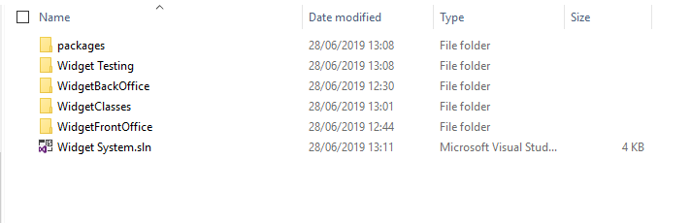
(Clearly you need to modify the above based on the system/sub system you are creating. If you are selling trainers then where I state widget, you state trainers.)
We will look at how to configure Visual Studio to allow us to do this.

Solutions and Projects
Visual Studio allows us to create both solutions and projects.
A project is typically an application of some sort, for example, a desktop application, a web site or a class library (to name a few).
A solution is container that allows us to work on multiple projects at the same time.
Start Visual Studio and you should see the main screen for the program.
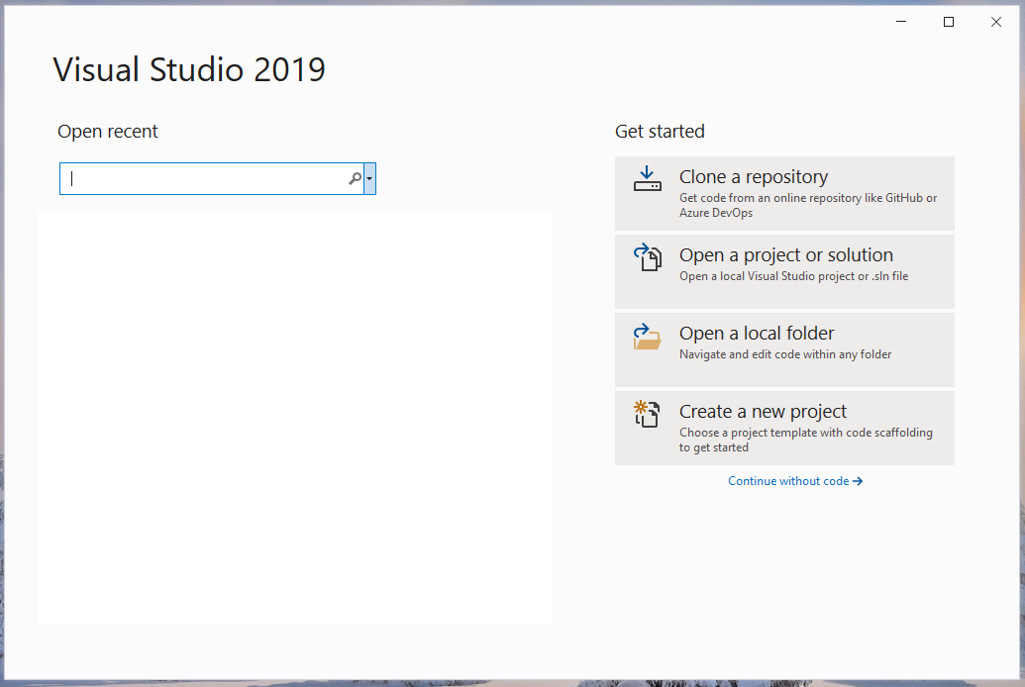
The simplest option at the moment is to press “Continue without code” which will bring you to the main interface for the program…
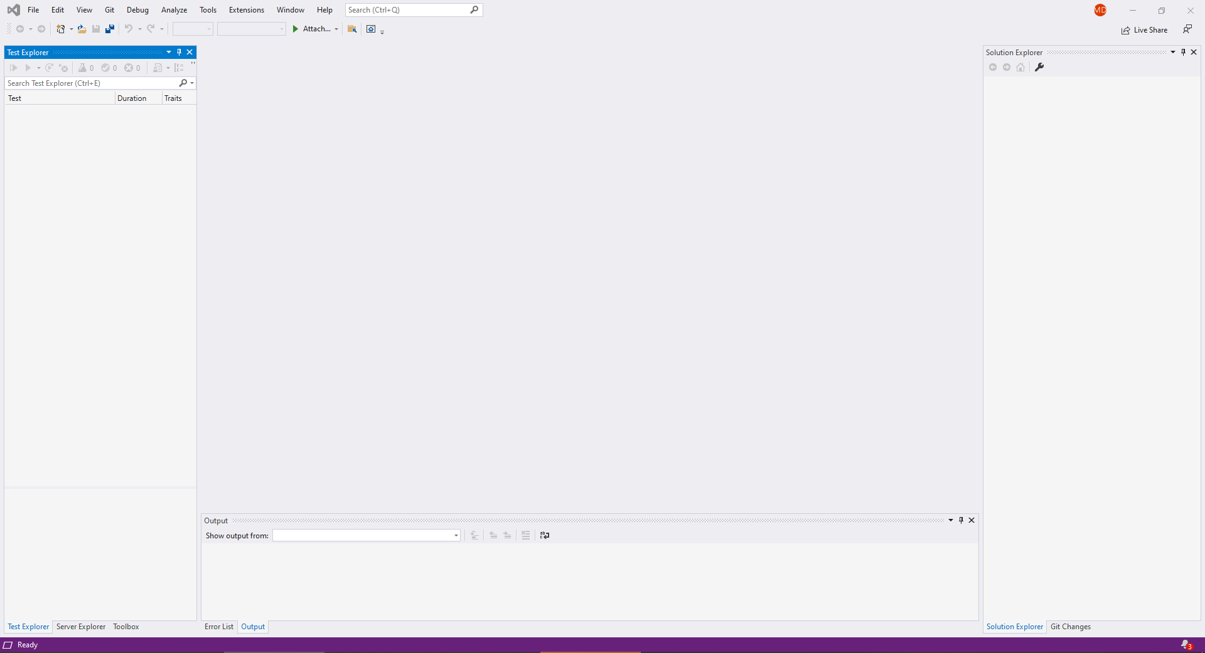

Creating the Solution
To create the solution that will allow us to manage the different projects we plan to create do the following.
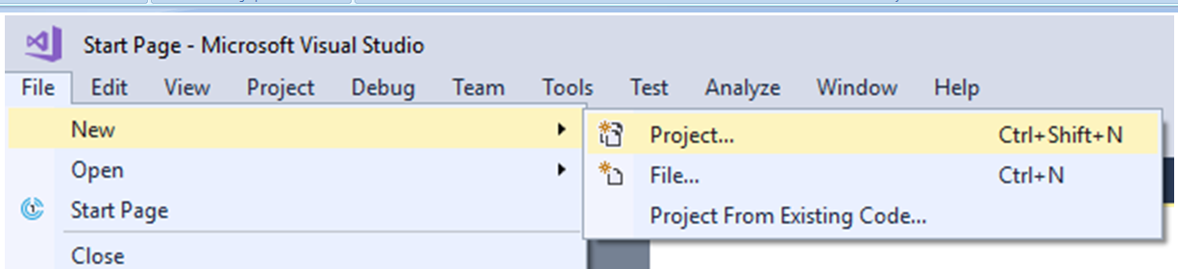
Select File – New – Project
(A solution is technically a type of project in Visual Studio!)
Under “Other Project Types” select “Visual Studio Solutions”.
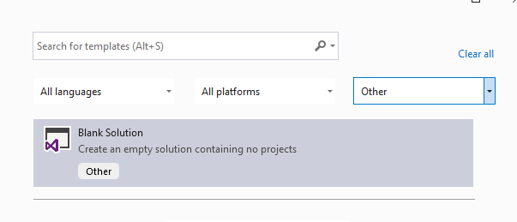
Press next.
Give the solution a suitable name in my case “Widget System” and decide on a suitable path for the solution.
Press Create and you should see something like this in the solution explorer…
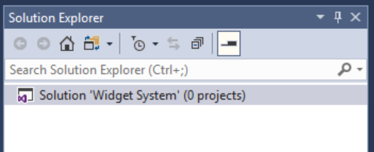
Notice that we didn’t need to specify a language for the solution.
The nice thing about creating solutions in Visual Studio is that the projects we add to it may be in any language supported by Visual Studio.
There are many different combinations allowed for by this configuration.

Creating the Presentation Layers
As you will hopefully discover one of the nice things about this configuration is that we may create multiple interfaces for our system all sharing the same class library.
Some examples of different interfaces might be...
- A customer facing web site
- A staff facing admin system
- A mobile app
- Other system based admin processes
We will create a few examples here to give you a sense of what is possible.

Creating the Staff Facing Back Office Project
For the first example we will create a staff facing admin system.
This will not be intended for customers and in this case will not be a web application but rather a Windows desktop application.
To do this we will need to add a new project to the existing solution.
Right click on the solution in Visual Studio and select Add – New Project…
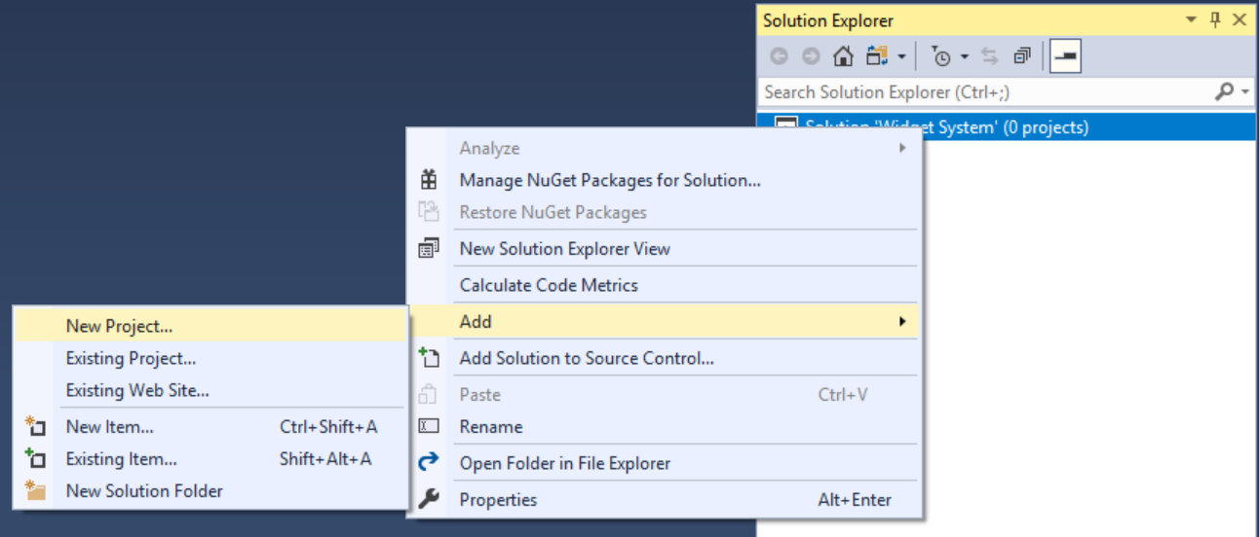
Select the following options for the new project…
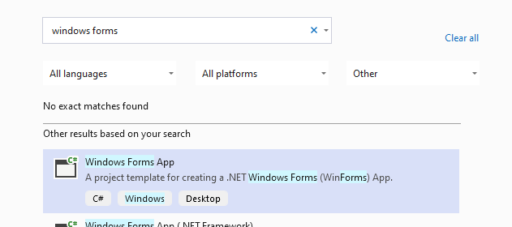
Make sure that the language is C#, the name of the project is WidgetBackOffice and the path points to the folder for your solution.
Press next and make sure that the framework is .NET (Not .NET core)
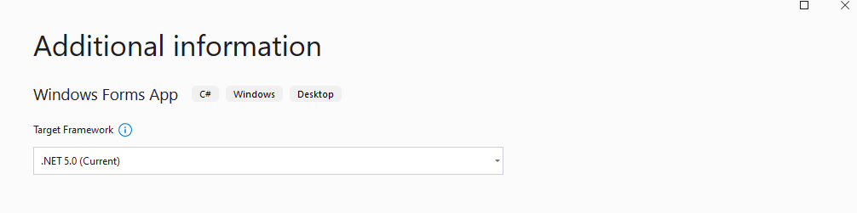
Press Create and you should see the following in the solution explorer…
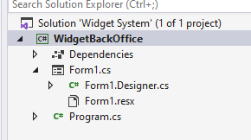
Notice also that Visual Studio has created a default form.
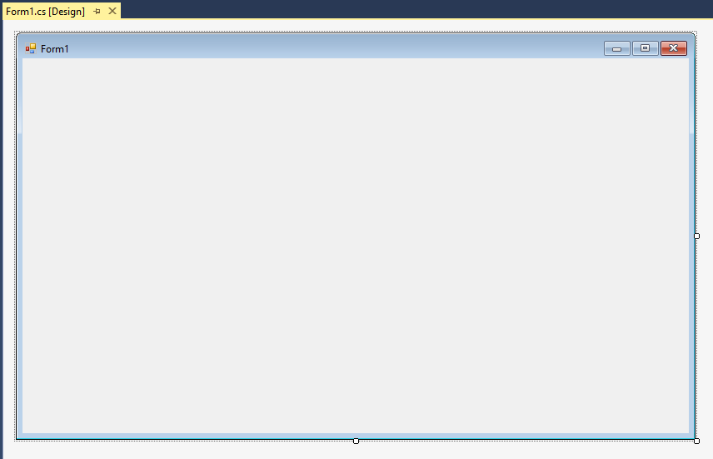

Run the project and see what happens, you should see the default form of the new desktop application...
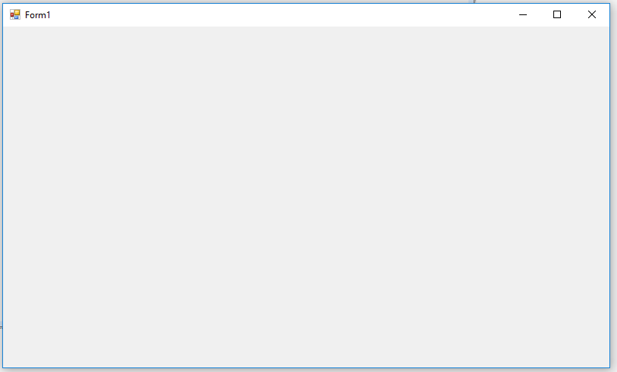
Close the program and go back to Visual Studio.

Creating the Customer Facing Web Project
Having created the back office for the application we need to set up the public facing web site.
Again, right click on the solution and select Add - New Project…
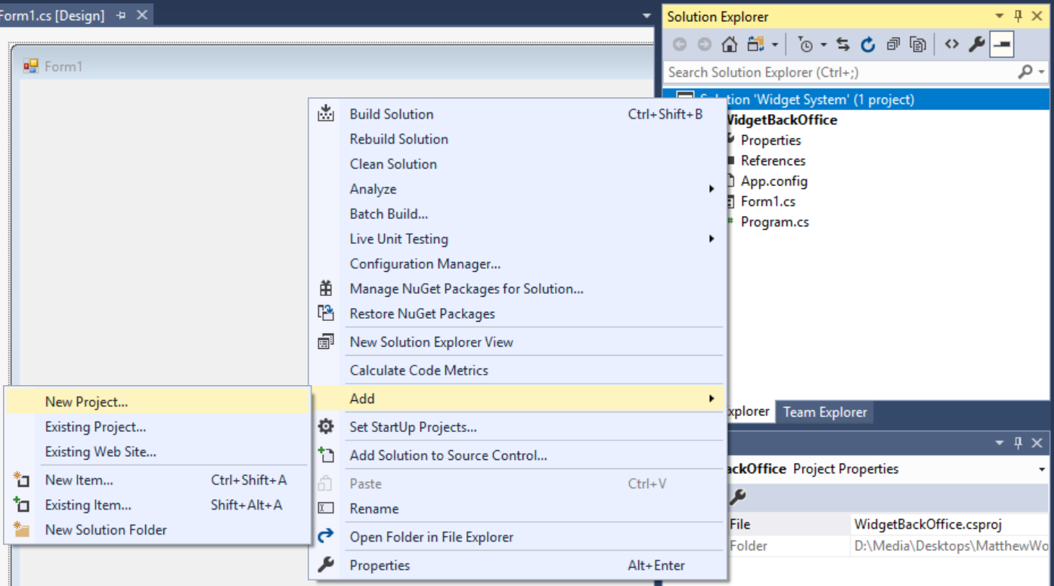
Locate ASP.Net empty web site…
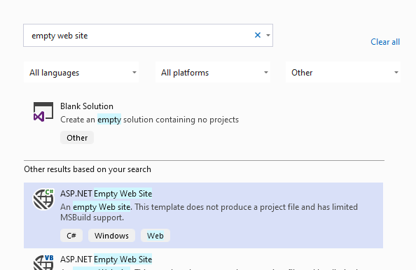
Press next.

Set up the new web site like so…
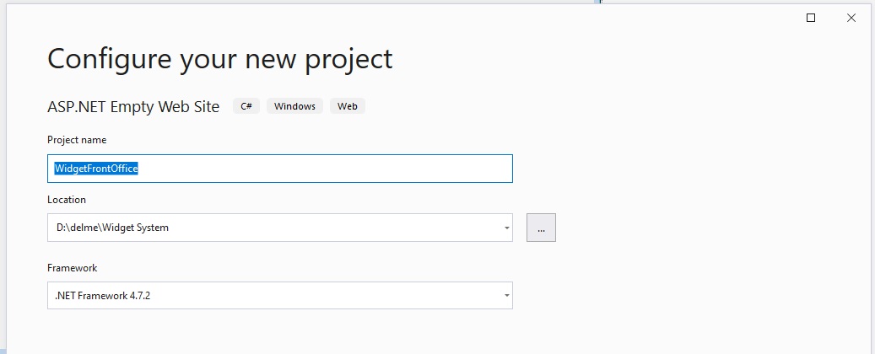
Make sure that the language is C# and that you are creating the web site (WidgetFrontOffice) inside your solution folder.
Press Create and you should now see the project in your solution alongside the first project...
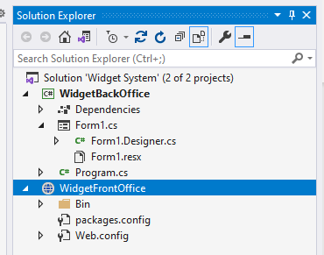

Run the program and see what happens, you should see the main page for the first project displayed still...
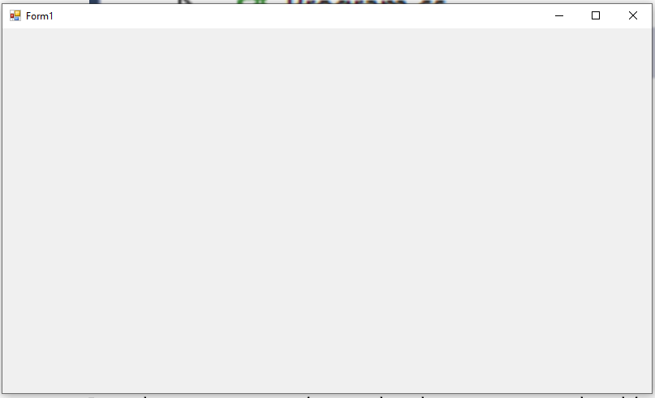
Why?
Given that we have two projects we need to tell Visual Studio which project it is supposed to run at start up.
Stop the program and right click on the new web site...
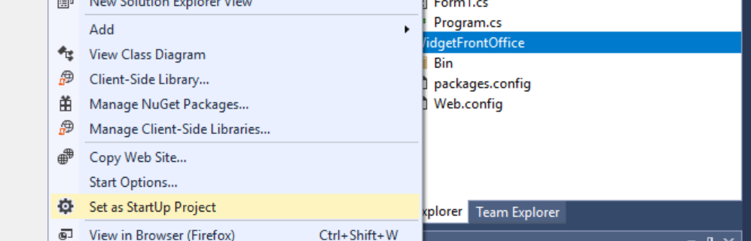
“Select set as StartUp Project”
Now run the program, what happens?
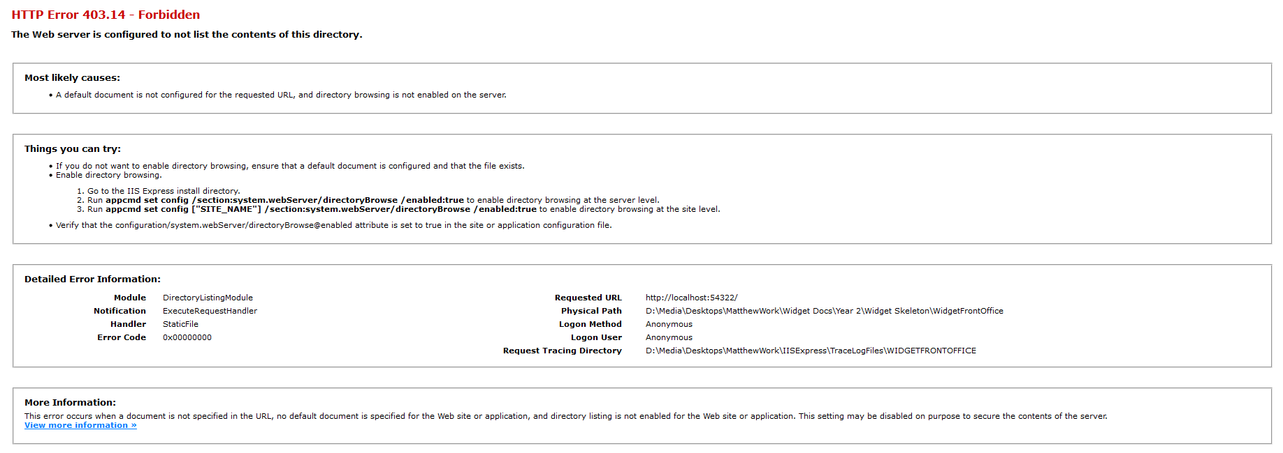
Now what is the problem?
Unlike a Windows desktop application, the web site configuration we chose does not automatically create a default page for the site.

Creating the Default Page
Right click on the web-site and select ADD – Add New Item...
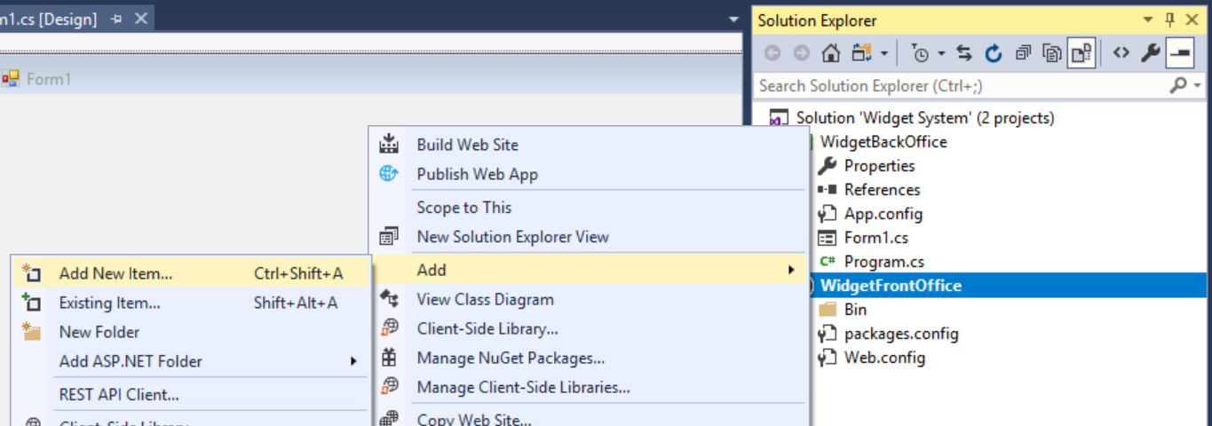
In the following screen create the default web form Default.aspx...
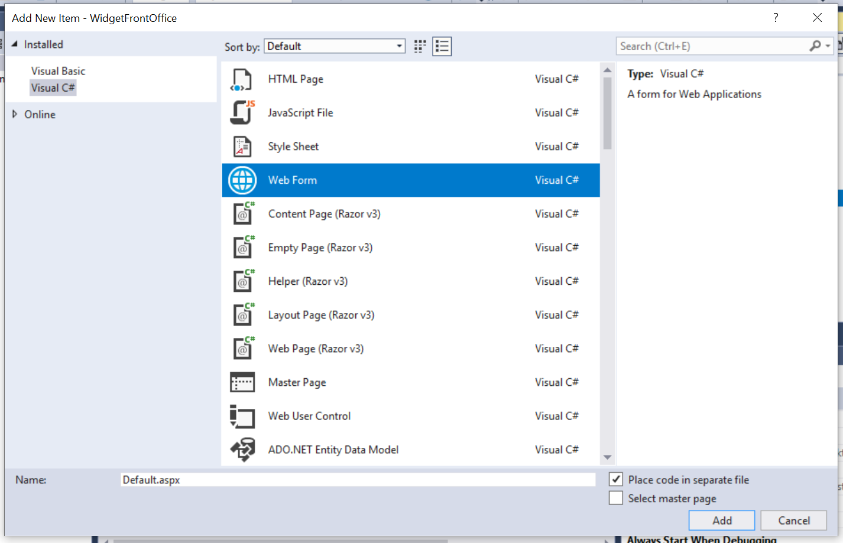
(Make sure you set the language to C#)
Press OK and you should see the new page in the web site...
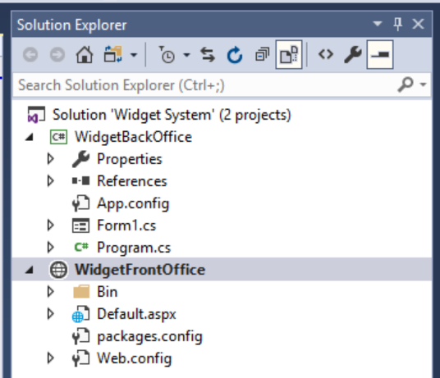
Run the program and you should find that the web site now has a (blank) start page.
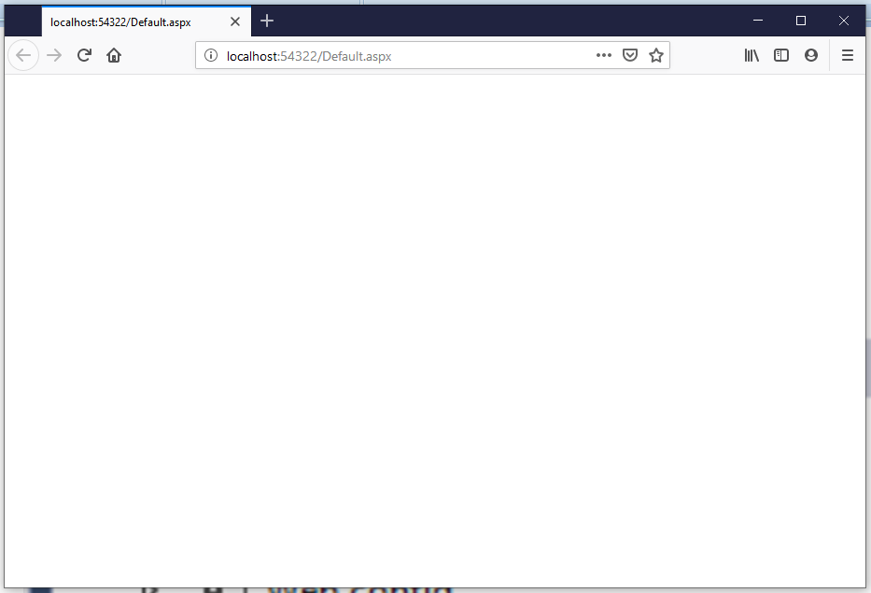
Not much to look at but we know that all is working OK.

Creating the Class Library
To create the middle layer, we are going to create a new project called a Class Library.
Why?
Having a single class library means that any code we create in one project may be re-used in other projects we create in the future.
It saves a great deal of repeated work.
To create the class library right click on the solution and add a new project…
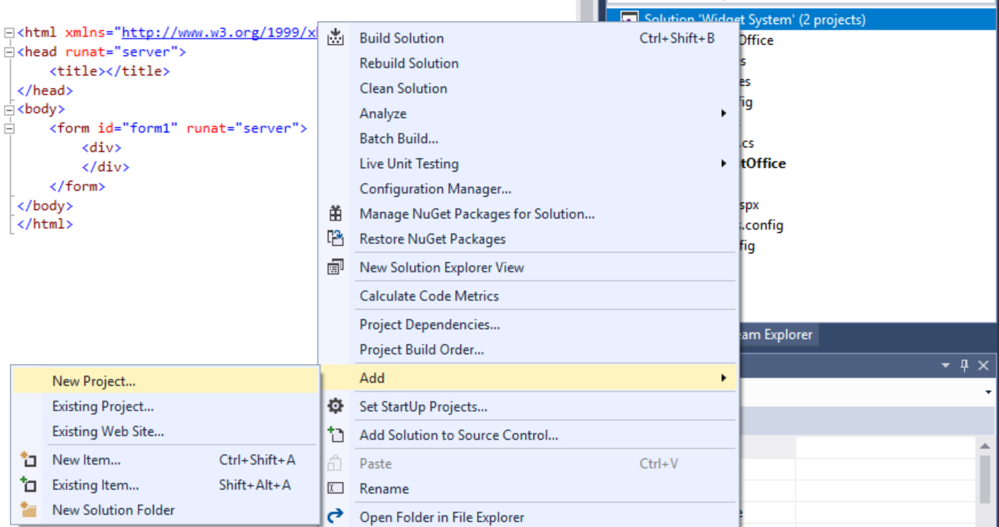

Add a class library for ,NET framework (not .NET core)
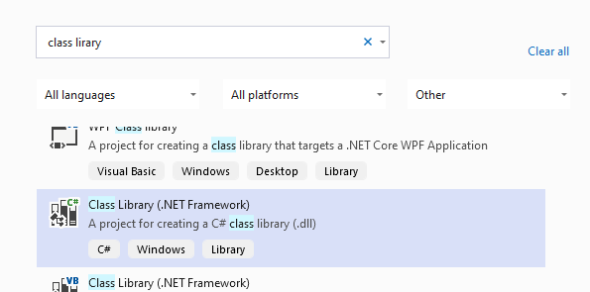
Press next.

Set up the class library project as follows…
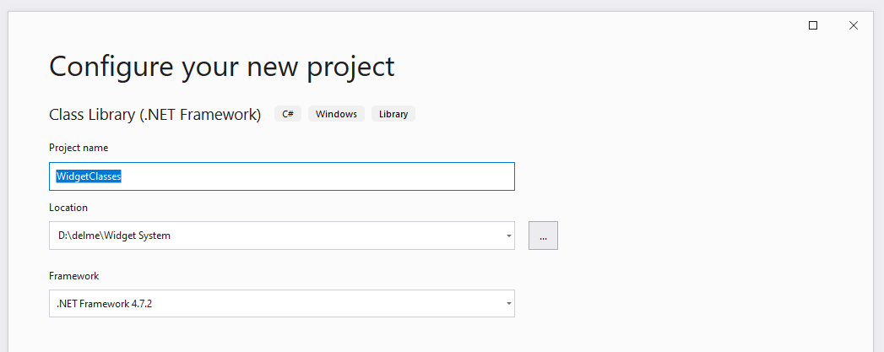
As always make sure that the class library is in the same folder as your other projects in the solution and that the selected language is C#.
Press OK and the solution should now look something like this…
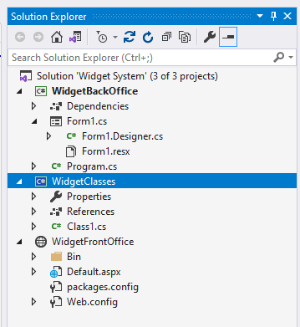
Visual Studio will create a default class template for you. Delete Class1.cs…
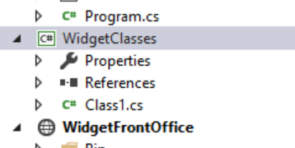

Once deleted, right click on the class library and add a new class…
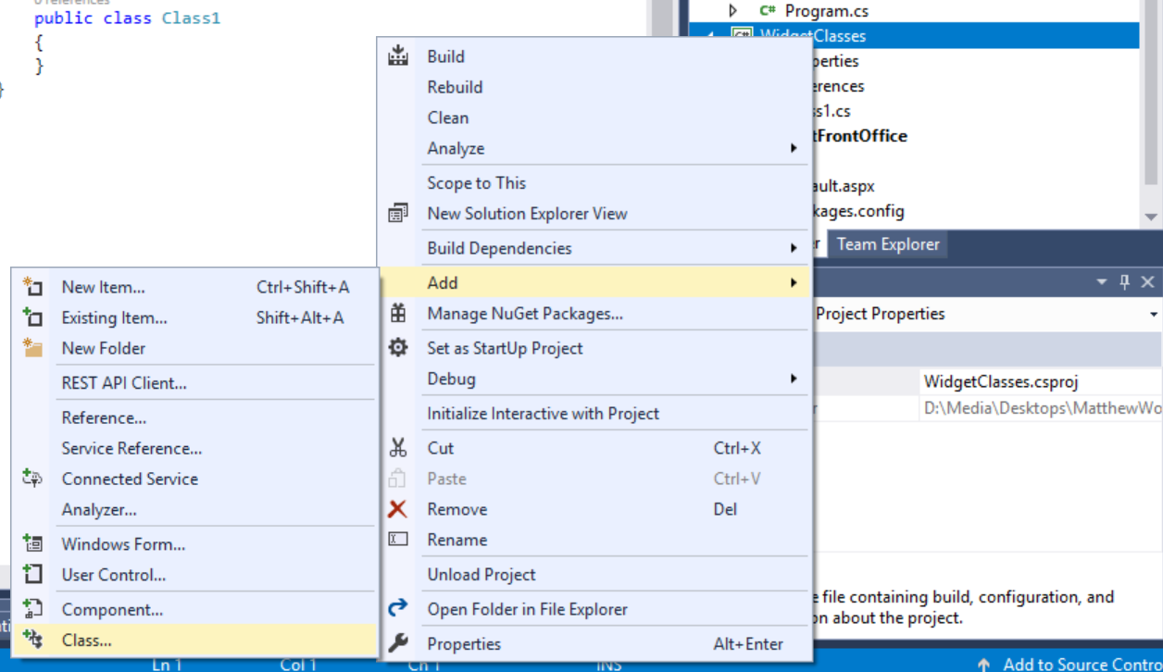
The first class we will add is the class we will use for connecting to the database.
Set the name of the class as clsDataConnection…
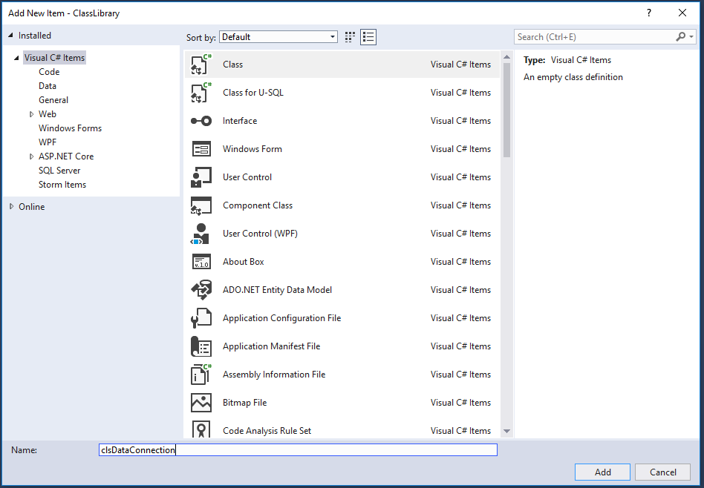
Press Add and the class will be created with some default code…
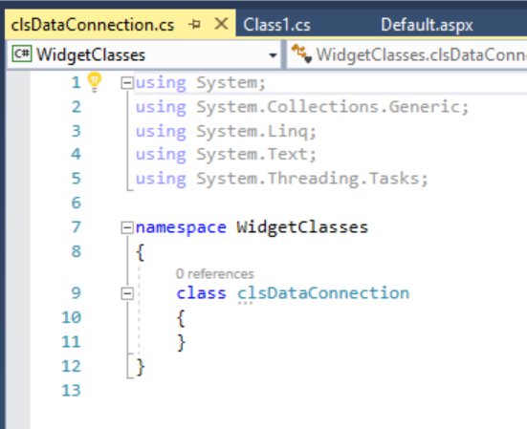

Namespaces
Notice in the above code that there is a namespace called WidgetClasses. The namespace is a way of organizing classes in the library such that they are grouped together. For example, you could have a namespace called graphics with all classes related to generating images organised in that namespace.
We are not interested in looking at namespaces in this but we will need to make sure that the WidgetClasses namespace is included in our classes.
Copy the code for the class from the module web site.
Delete the default code and replace it with the code from the module web site.
Don’t forget to add in your namespace at the top of the code…
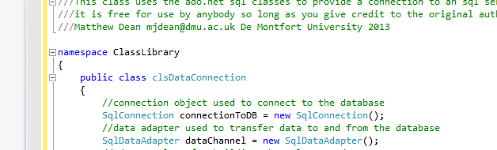
With a closing bracket at the very end…
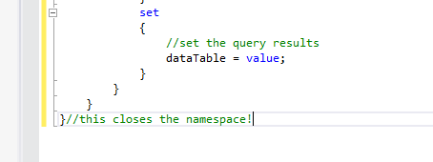
Close and save the data connection, your class library should look like this now...
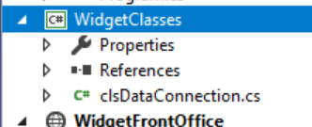

Creating the Test Project
The last project we are going to create is a test project.
The test project will contain classes that allow us to automate the testing process.
As with the other projects right click on the solution and create a new project...
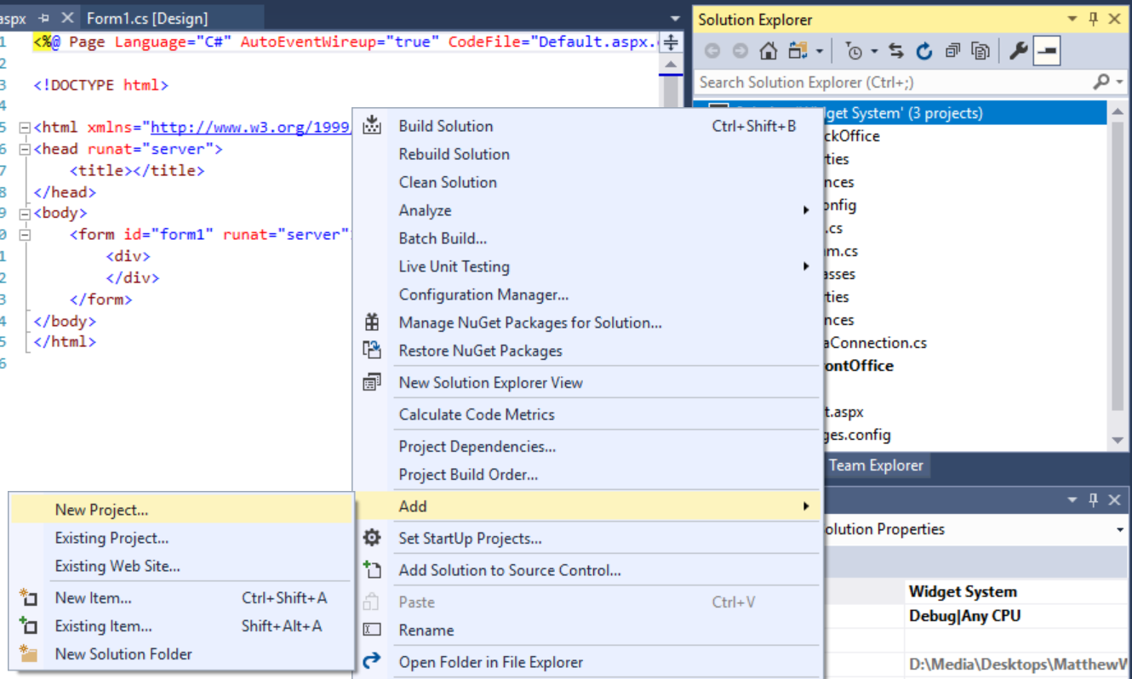
This time select C# Unit Test Project
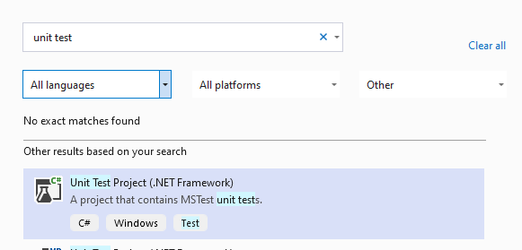
(Again .NET not .Net core)
Press Next.
giving it a suitable name...
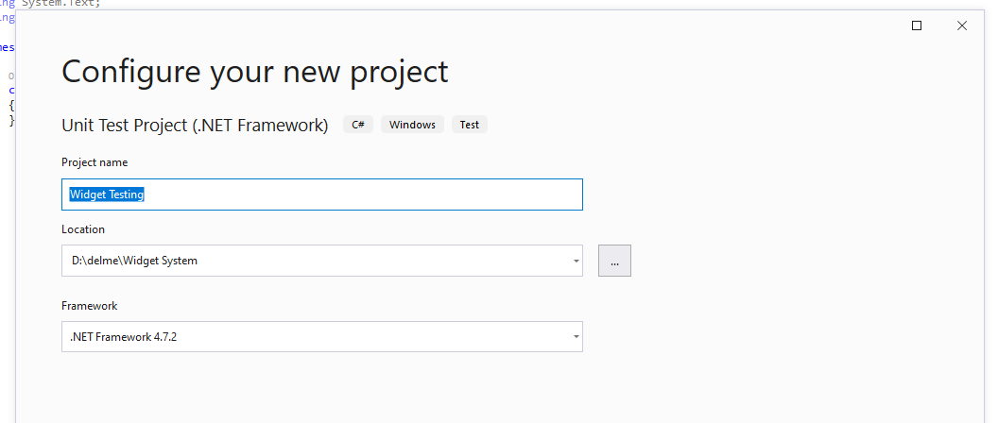
Press “create”.
The test project will create a default test class...
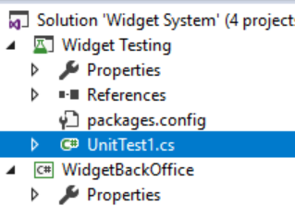
We don’t need this so delete it.

Checking the Configuration
It really is worthwhile checking the folder structure for the skeleton as resolving problems now save a lot of pain later.
Go to the folder where you saved the solution and you should see something like the following structure...
If it looks different or you are in any doubt, ask your tutor before continuing.

Adding the Skeleton to Source Control
You now have the main elements of the skeleton completed so we may upload to Git...
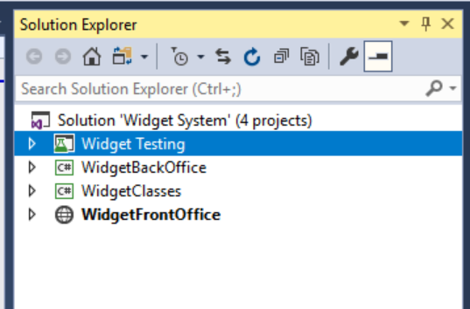
One aspect notably absent is the data layer but we will look at that later on as it requires special consideration.
Having set up the solution locally we need to set up GitHub with a suitable repo for us to upload the skeleton into the cloud.
From the web interface one member of your team (the owner of the skeleton) needs to create a new repo as before...
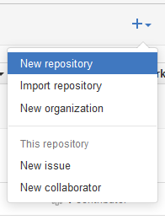
Set up the repo like so…
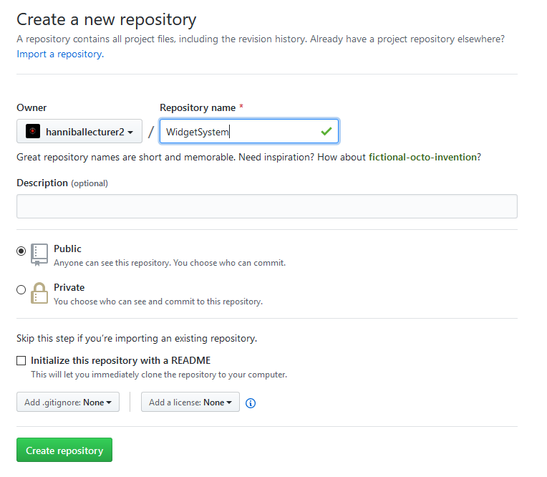
In this example do not initialise the repository with a readme!
Press create repository.
On the next screen, you will see the following…
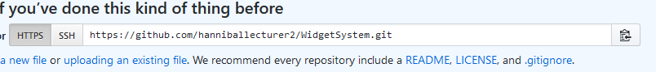
Note the URL that has been given to the repo.
Copy and paste this URL somewhere as you will need it in a moment.
Go back over in Visual Studio locate Git Changes in the bottom right…

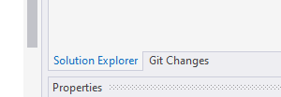
Select Create Git Repository…
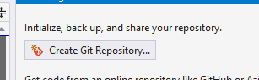
Select from the next screen “Existing Remote”
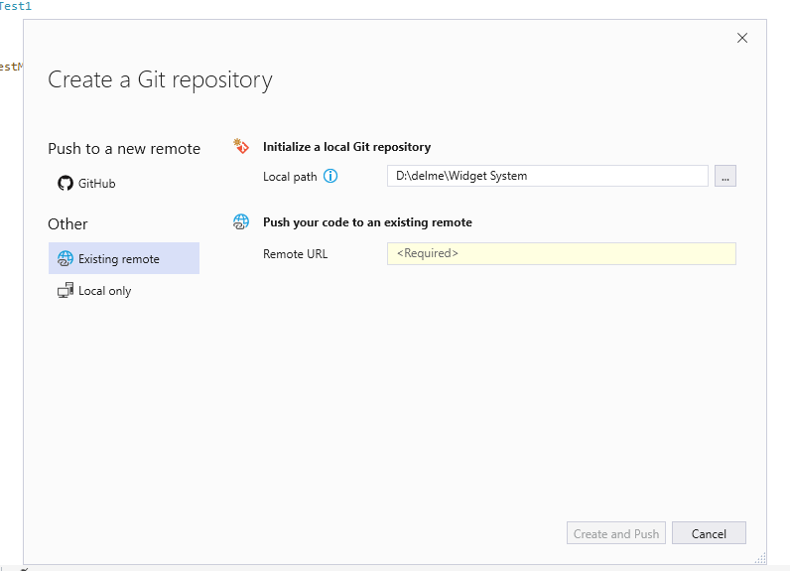
Paste the URL for your repository here…
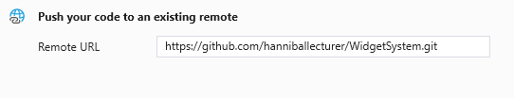
Press create and push
(At this point it is likely to ask you to sign in)
After a few moments you should see a progress bar indicating that the code has been uploaded to Git.
To really check it worked look at the code for the repo from the Git web interface you will see the following…
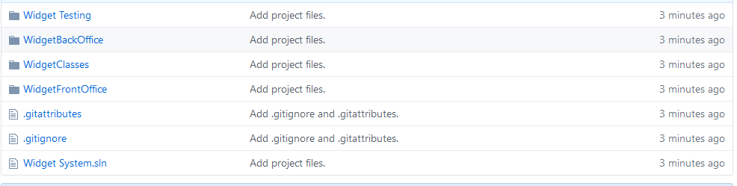

Adding Other Developers
This has all been very nice so far, but this is hardly what you would call working as a team.
The next thing to do is to add some people who will be able to collaborate on the project.
To allow others to work on your code you will need to create a new collaborator.
Under settings find the section for collaborators...
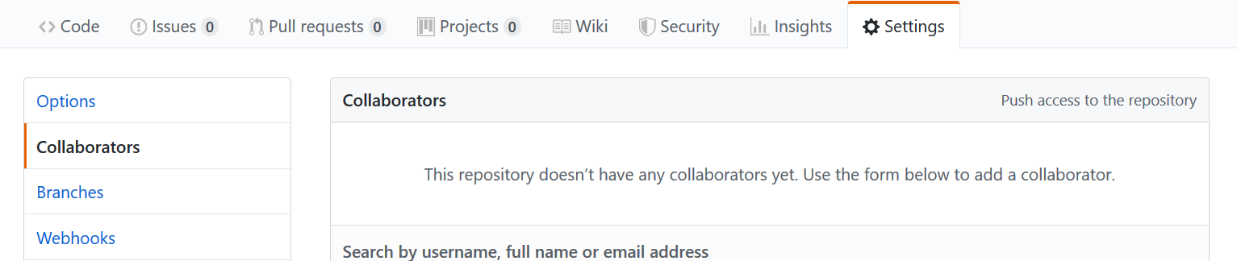

Invitations are sent internally to Git via its own messaging system as well as the person’s email account.
Once you have set up your team with access to the project they will then need to clone the files to their local machine.

Cloning the Repo in Visual Studio
Now that the master repository has been set up and invitations have been accepted you should all be able to clone an individual copy of the master to your own local machine.
When each team member starts Visual Studio you should see the following start screen…

This will allow you to enter the URL for the source and specify a location for the downloaded files. Always remember to clone the repository to an empty folder you have created yourself.
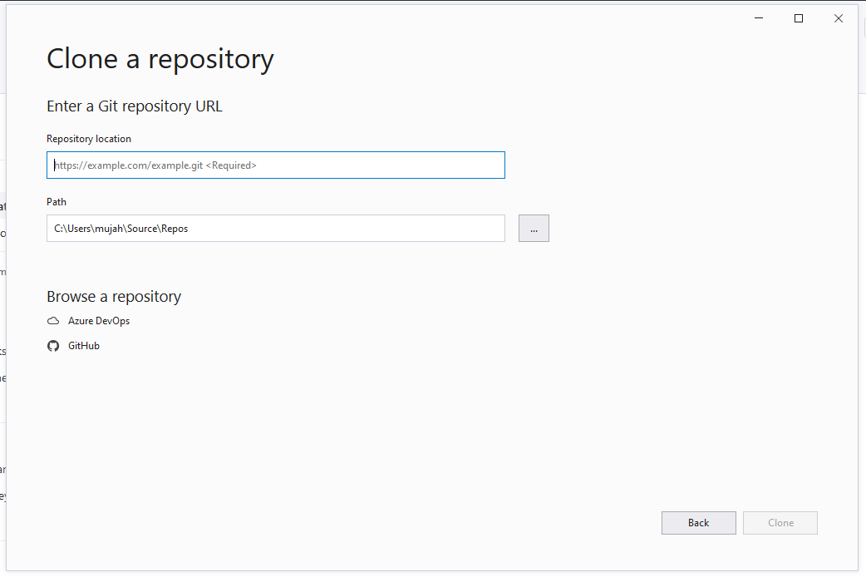

Checking the Clone
If you have got this far and each team member has a clone of the master repository you may check the setup as follows...
Look at the folder structure...
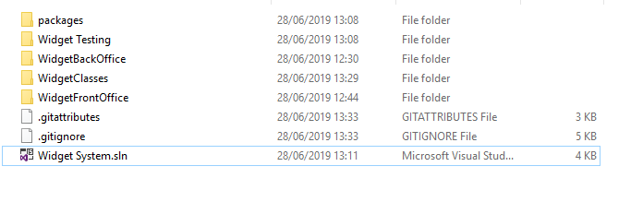
It should be exactly the same for each member of the team. If not, something has gone wrong with the process and you must fix this before continuing.
Also open the solution in Visual Studio...
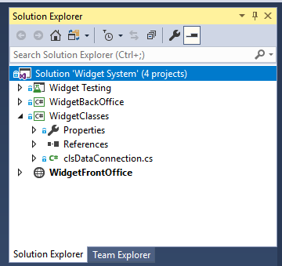
Again, it should look identical on each team member’s computer.

Last thing
All we have done so far is set up the master repository and prove that each team member is able to clone a copy successfully. We are not at the stage yet where, as a team you may work together to start designing and building the system.
In the next session you will all do some practice exercises such that when you start to collaborate you have the skills you need.

